**Program to develop a linear regression model for forecasting time series data.**

**1. Import Libraries**

import pandas as pd

from sklearn.linear_model import LinearRegression

from sklearn.metrics import mean_squared_error, r2_score

import matplotlib.pyplot as plt

pandas: For reading and handling the dataset.

LinearRegression: The linear regression model from scikit-learn.

mean_squared_error, r2_score: For evaluating the performance of the model.

matplotlib.pyplot: For plotting the results.

**2. Load the Dataset**

data = pd.read_csv('OzoneHole_Data.csv')

**3. Prepare the Data**

X = data['Year'].values.reshape(-1, 1)

y_area = data['Hole Area'].values

y_ozone = data['Minimum Ozone'].values

X is the feature (independent variable), which is the Year. It's reshaped into a 2D array as required by scikit-learn.

y_area and y_ozone are the target variables (dependent variables) for prediction.

### **4. Initialize the Linear Regression Models**

model_area = LinearRegression()

model_ozone = LinearRegression()

**5. Train the Models:**

model_area.fit(X, y_area)

model_ozone.fit(X, y_ozone)

**6. Make Predictions**

y_area_pred = model_area.predict(X)

y_ozone_pred = model_ozone.predict(X)

**7. Evaluate the Models**

mse_area = mean_squared_error(y_area, y_area_pred)

r2_area = r2_score(y_area, y_area_pred)

mse_ozone = mean_squared_error(y_ozone, y_ozone_pred)

r2_ozone = r2_score(y_ozone, y_ozone_pred)

**Mean Squared Error (MSE)** measures the average squared difference between actual and predicted values (lower is better).

**R² Score** measures how well the model explains the variance in the target variable (closer to 1 is better).

### **8. Visualize the Results**

plt.figure(figsize=(14, 6))

plt.subplot(1, 2, 1)

plt.scatter(X, y_area, color='blue', label='Actual Area')

plt.plot(X, y_area_pred, color='red', label='Predicted Area')

plt.title('Ozone Hole Area Over Time')

plt.xlabel('Year')

plt.ylabel('Hole Area')

plt.legend()

plt.subplot(1, 2, 2)

plt.scatter(X, y_ozone, color='green', label='Actual Ozone')

plt.plot(X, y_ozone_pred, color='orange', label='Predicted Ozone')

plt.title('Minimum Ozone Over Time')

plt.xlabel('Year')

plt.ylabel('Minimum Ozone')

plt.legend()

plt.tight_layout()

plt.show()

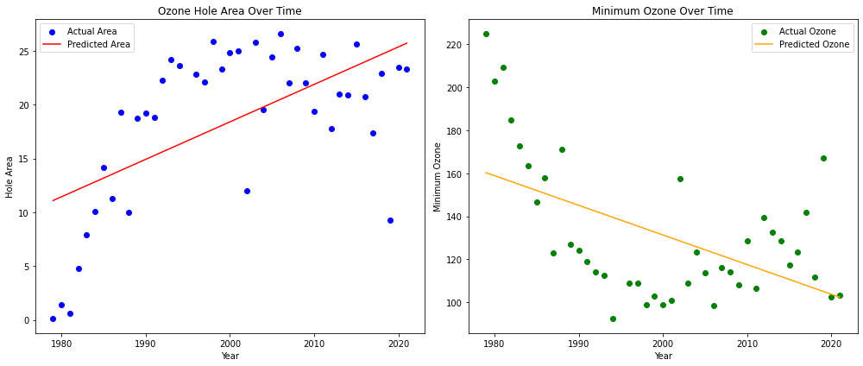

**Result**

Thus successfully implemented a program related to ozone depletion using machine learning